Discovery 12: Implementing HSRP
Introduction

Hot Standby Router Protocol (HSRP) is a Cisco proprietary protocol that was developed to allow several multilayer switches or routers to appear as a single gateway IP address.

In this guided discovery, you will work with HSRP. Hosts on IP networks usually only have a single IP address that is configured as their default gateway. HSRP allows two physical routers to work together in an HSRP group to provide a virtual IP address and an associated virtual MAC address.

The end hosts use the virtual IP address as their default gateway and learn the virtual MAC address via ARP. One of the routers in the group is active and responsible for the virtual addresses. The other router is in a standby state and monitors the active router.

If there is a failure on the active router, the standby router assumes the active state. The virtual addresses are always functional, regardless of which physical router is responsible for them. The end hosts are not aware of any changes in the physical routers.

In the lab, you will configure and learn about the following HSRP parameters:
- HSRP group
- HSRP priority
- HSRP pre-emption
- HSRP timers
- HSRP states
Note
In this discovery, HSRP, which is an example of First Hop Redundancy Protocol (FHRP), can be configured on Layer 3 switches and routers. In this discovery, HSRP is configured on routers because the Special build of IOS for Linux (IOL) that the lab uses does not support the HSRP feature on switches.

Your configuration task is as follows:
Configure and Tune HSRP
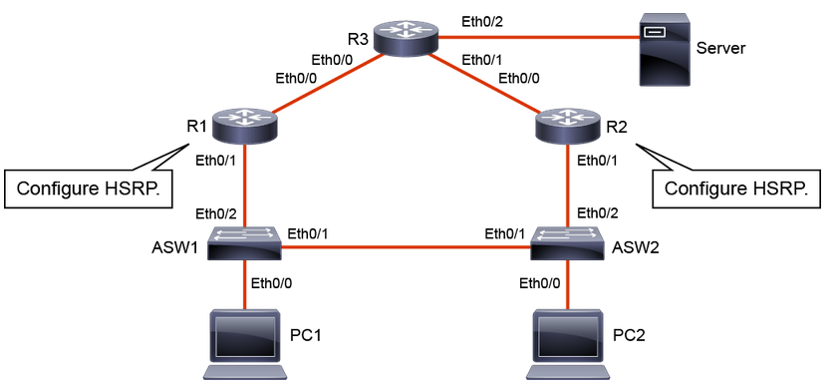

Task 1: Configure and Tune HSRP

Understanding HSRP

Hot Standby Router Protocol (HSRP) is an FHRP that allows for transparent failover of the first-hop IP device (default gateway). Most IP hosts have an IP address of a single router configured as the default gateway. When you use HSRP, the HSRP virtual IP address is configured as the default gateway for the host instead of the IP address of the router.

You should note the following about HSRP:
- HSRP defines a group of routers—one active and one standby.
- Virtual IP and MAC addresses are shared between the two routers.
- To verify HSRP state, use the show standby command.
- HSRP is Cisco proprietary, and VRRP is an open standard.
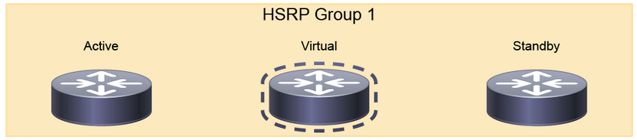
HSRP defines a standby group of routers, with one router that is designated as the active router. HSRP provides gateway redundancy by sharing IP and MAC addresses between redundant gateways. The protocol consists of virtual MAC and IP addresses that two routers that belong to the same HSRP group share between each other.
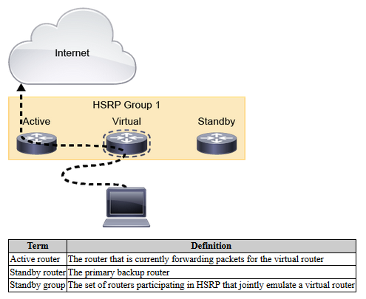
- The HSRP Active route has the following characteristics:
  - Responds to default gateway ARP requests with the virtual router MAC address
  - Assumes active forwarding of packets for the virtual router
  - Sends hello messages
  - Knows the virtual router IP address
- The HSRP Standby route has the following characteristics:
  - Sends hello messages
  - Listens for periodic hello messages
  - Assumes active forwarding of packets if it does not hear from active router
Hosts on the IP subnet that are protected by HSRP configure their default gateway with the HSRP group virtual IP address. The packets that are received on the virtual IP address are forwarded to the active router.

The function of the HSRP standby router is to monitor the operational status of the HSRP group and to quickly assume the packet-forwarding responsibility if the active router becomes inoperable.

HSRP is a Cisco proprietary protocol, and VRRP is a standard protocol. Beyond this fact, the differences between HSRP and VRRP are very slight.
HSRP Group
An HSRP group is a set of HSRP devices that emulate a virtual router. Following is command to configure HSRP group:
Router( config-if)# standby group number ip ip-address
By default, the group number would be set to group 0
With HSRP version 1, a group number can be any integer between 0 and 255.
All routers in an HSRP group exchange hellos.
Roles of routers in HSRP group are elected based on exchange of hello messages.
HSRP active and standby routers send hello messages to the multicast address 224.0.0.2, UDP port 1985.

In the lab, you have assigned both routers a common HSRP group—group 1. If you configure HSRP on a multilayer switch, it is a good practice to configure the HSRP group number as equal to the VLAN number, this also makes troubleshooting easier. HSRP group numbers are locally significant. For example, HSRP group 1 on VLAN 22 is independent from HSRP group 1 on VLAN 33.

One of the two routers will be elected as active and the other will be elected as standby. If you had more routers in your HSRP group, they would be in the listen state. Roles are elected based on the exchange of HSRP hello messages. When the active router fails, the other HSRP routers stop seeing hello messages from the active router. The standby router then assumes the role of the active router. If other routers participate in the group, they then contend to be the new standby router. Should both the active and standby routers fail, all other routers in the group contend for the active and standby router roles. As the new active router assumes both the IP and the MAC address of the virtual router, the end stations see no disruption in the service. The end stations continue to send packets to the virtual router MAC address, and the new active router forwards the packets toward their destination.

HSRP active and standby routers send hello messages to the multicast address 224.0.0.2, UDP port 1985.

The ICMP protocol allows a router to redirect an end station to send packets for a particular destination to another router on the same subnet. That is, if the first router knows that the other router has a better path to that particular destination. As was the case for default gateways, if the router to which an end station has been redirected for a particular destination fails, then the end-station packets to that destination are not delivered. In standard HSRP, this action is exactly what happens. For this reason, it is recommended disabling ICMP redirects if HSRP is turned on.
Activity

Step 1: Configure the GigabitEthernet 0/1 (LAN-facing) interface of R1 with the 192.168.1.3/24 IP address and an HSRP group 1 standby IP address of 192.168.1.1.

The IP address 192.168.1.1 is the HSRP virtual IP address that is also configured as the default gateway IP address on PC1 and PC2.
On R1, enter the following commands:
R1#conf t
Enter configuration commands, one per line. End with CNTL/Z.
R1(config)# interface GigabitEthernet 0/1
R1(config-if)# ip address 192.168.1.3 255.255.255.0
R1(config-if)# standby 1 ip 192.168.1.1

Step 2: On R2, configure the GigabitEthernet 0/1 (LAN-facing) interface with the 192.168.1.2/24 IP address and an HSRP group 1 standby IP address of 192.168.1.1.

Note
Both R1 and R2 must have the same HSRP standby IP address that is configured.
On R2, enter the following commands:
R2#conf t
Enter configuration commands, one per line. End with CNTL/Z.
R2(config)# interface GigabitEthernet 0/1
R2(config-if)# ip address 192.168.1.2 255.255.255.0
R2(config-if)# standby 1 ip 192.168.1.1

Step 3: On R1, verify the Address Resolution Protocol (ARP) table.
On R1, enter the following commands:
R1# show ip arp

The IP address and the corresponding MAC address of the virtual router are maintained in the ARP table of the active router in an HSRP group.

The HSRP MAC address is in the following format: 0000.0c07.acXX, where XX is the HSRP group number converted from decimal to hexadecimal. Clients utilize this MAC address to forward data.

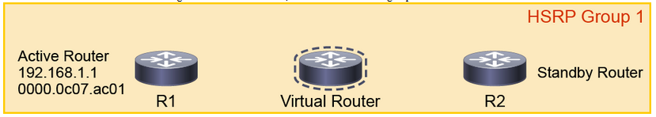
Investigate the ARP table of R1 to see the MAC address of the HSRP virtual router.

Forwarding Through the Active Router
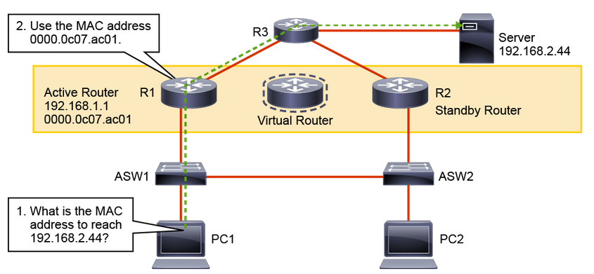

All the routers in an HSRP group have specific roles and interact in specific ways.

The virtual router is simply an IP and MAC address pair that end devices have configured as their default gateway. The active router will process all packets and frames that are sent to the virtual router address. The virtual router processes no physical frames.

Within an HSRP group, one router is elected to be the active router. The active router responds to traffic for the virtual router. If an end station sends a packet to the virtual router MAC address, the active router receives and processes that packet. If an end station sends an ARP request with the virtual router IP address, the active router replies with the virtual router MAC address. In this example, R1 assumes the active role and forwards all frames that are addressed to the well-known MAC address of 0000.0c07.acXX, where XX is the HSRP group identifier. While ARP and PING will use the HSRP virtual MAC address the router will respond to traceroute with its own MAC address. This is useful in troubleshooting to determine which actual router is used for the traffic flow.

During a failover transition the newly active router will send three gratuitous ARP requests so that the Layer 2 devices can learn the new port of the virtual MAC address.

HSRP Priority
- The active router is elected based on the HSRP priority.
- Use a value between 0 and 255.
- The default priority is 100.
Router(config)# interface GigabitEthernet number
Router(config-if)# standby group number priority <1-255>

The HSRP priority is a parameter that enables you to choose the active router between HSRP-enabled devices in a group. The priority is a value between 0 and 255. The default value is 100. The device with the highest priority will become active.

If HSRP group priorities are the same, the device with the highest IP address will become active. In this example, that is R1.

Setting priority is wise for deterministic reasons. You want to know how your network will behave under normal conditions. Knowing that R2 is the active gateway for VLAN 1 clients enables you to write good documentation.

However, now that you have changed the R2 priority to 110, it will not automatically become the active router because pre-emption is not enabled by default. Pre-emption is the ability of an HSRP-enabled device to trigger the reelection process.

Step 4: On R2, configure the HSRP group 1 with a priority of 110.
On R2, enter the following commands:
R2(config)# interface GigabitEthernet 0/1
R2(config-if)# standby 1 priority 110

Configuring HSRP Pre-Empt
- This configuration pre-empts HSRP election if a device with a higher priority comes online.
- It is disabled by default.
Router(config-if)# standby group number preempt

Step 5: On both R1 and R2, configure the GigabitEthernet 0/1 HSRP group 1 interfaces with pre-emption.
On R1 and R2, enter the following commands:
R1(config)# interface GigabitEthernet 0/1
R1(config-if)# standby 1 preempt

R2(config)# interface GigabitEthernet 0/1
R2(config-if)# standby 1 preempt
R2(config-if)#

After you enable pre-emption on R2, R1 will change its state to "standby" and R2 will change its state to "active."

Configuring HSRP Timers

Configure the hello time and hold time in millisecond values.
Router (config-if)# standby group-number timers [msec] hellotime [msec] holdtime

The holdtime should be at least three times greater than the hello time.

The failover delay configuration should also take into account IGP convergence delay.

Configure the pre-empt delay timer so that pre-emption occurs after the HSRP device has fully rebooted and has established full connectivity to the network.

A hello message contains the priority of the router, the hello time, and the holdtime parameter values. The hello timer parameter value indicates the interval of time between the hello messages that the router sends. The holdtime parameter value indicates for how long the current hello message is considered valid. The standby timer includes an msec parameter to allow for subsecond failovers. Lowering the hello timer results in increased traffic for hello messages and should be used cautiously.

If an active router sends a hello message, the receiving routers consider the hello message to be valid for one holdtime period. The holdtime value should be at least three times the value of the hello time. The holdtime value must be greater than the value of the hello time.

You can adjust the HSRP timers to tune the performance of HSRP on distribution devices, as a result of that increasing their resilience and reliability in routing packets off the local VLAN.
By default, the HSRP hello time is 3 seconds and the holdtime is 10 seconds, which means that the failover time could be as much as 10 seconds for clients to start communicating with the new default gateway. Sometimes, this interval may be excessive for application support. The hello time and the holdtime parameters are configurable. To configure the time between the hello messages and the time before other group routers declare the active or standby router to be nonfunctioning, enter the following command in the interface configuration mode:

Router (config-if)# standby group-number timers [msec] hellotime [msec] holdtime

The hello interval is specified in seconds unless the msec keyword is used. This integer is from 1 through 255. The default is 3 seconds. The dead interval, also specified in seconds, is a time before the active or standby router is declared to be down. This integer is from 1 through 255, unless the msec keyword is used. The default is 10 seconds.

The hello and dead timer intervals must be identical for all the devices within the HSRP group.

To reinstate the default standby-timer values, enter the no standby group timers command.

Ideally, to achieve fast convergence, these timers should be configured to be as low as possible. Within milliseconds after the active router fails, the standby router can detect the failure, expire the holdtime interval, and assume the active role.

Note
Decreasing the HSRP timers will allow you to detect a first-hop failure faster. However, shorter HSRP timers mean more HSRP hello packets, which in turn means more overhead traffic.

Nevertheless, the timer configuration should also take into account other parameters that are relevant to the network convergence. For example, both HSRP routers may run a dynamic routing protocol. The routing protocol probably has no awareness of the HSRP configuration, and it sees both routers as individual hops toward other subnets. If HSRP failover occurs before the dynamic routing protocol converges, suboptimal routing information may still exist. In a worst-case scenario, the dynamic routing protocol continues seeing the failed router as the best next hop to other networks, and packets are lost. When you configure HSRP timers, make sure that they harmoniously match the other timers that can influence which path is chosen to carry packets in your network.

Pre-emption is an important feature of HSRP that allows the primary router to resume the active role when it comes back online after a failure or a maintenance event. Pre-emption is a desired behavior because it forces a predictable routing path for the VLAN traffic during normal operations. It also ensures that the Layer 3 forwarding path for a VLAN parallels the Layer 2 STP forwarding path whenever possible.

When a pre-empting device is rebooted, HSRP pre-emption communication should not begin until the distribution switch has established full connectivity to the rest of the network. This situation allows the routing protocol convergence to occur more quickly, after the preferred router is in an active state.

To accomplish this setup, measure the system boot time and set the HSRP pre-emption delay to a value that is about 50 percent greater than the boot time of the device. This value ensures that the primary distribution switch establishes full connectivity to the network before the HSRP communication occurs.

Step 6: On both R1 and R2, configure the GigabitEthernet 0/1 HSRP group 1 hello timer for 200 milliseconds, a holdtime of 750 milliseconds, and a pre-empt delay minimum of 300 milliseconds.
On R1 and R2, enter the following commands:
R1(config-if)#standby 1 timers msec 200 msec 750
R1(config-if)#standby 1 preempt delay minimum 300
R2(config-if)#standby 1 timers msec 200 msec 750
R2(config-if)#standby 1 preempt delay minimum 300

Step 7: On R1 and R2, verify the HSRP status.
On R1 and R2, enter the following commands:
R1# show standby

R2#show standby

R2#show standby brief

R1 is the standby router and R2 is the active router. The output of show standby can be condensed with the brief keyword.

HSRP State Transition
An HSRP router can be in one of five states.

State | Description
Initial | The state at the start. Also, it is the state after a configuration change or when an interface first comes up.
Listen | The router knows the virtual IP address. It listens for hello messages from other routers.
Speak | The router sends periodic hello messages and actively participates in the election of the active or standby router.
Standby | The router currently forwards packets that are sent to the group virtual MAC address. The router sends periodic hello messages.
Active | The router currently forwards packets that are sent to the group virtual MAC address. The router sends periodic hello messages.

When a router exists in one of these states, it performs the actions that are required by that state. Not all HSRP routers in the group will transition through all states. In an HSRP group with three or more routers, a router that is not the standby or active router will remain in the listen state. In other words, no matter how many devices that are participating in HSRP, only one device can be active and one other device in standby. All other devices will be in the listen state.
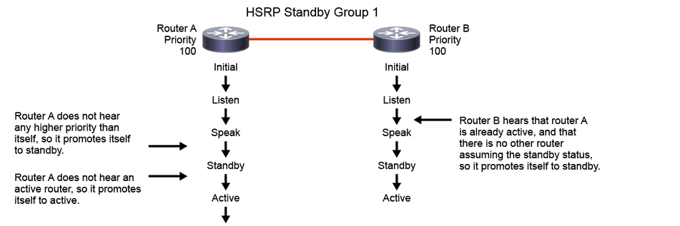
All routers begin in the initial state. This state is the starting state and it indicates that HSRP is not running. This state is entered via a configuration change, such as when HSRP is disabled on an interface or when an HSRP-enabled interface is first brought up, for instance when the no shutdown command is issued.

The purpose of the listen state is to determine if there are any active or standby routers already present in the group. In the speak state, the routers actively participate in the election of the active router, standby router, or both.

Each router uses three timers for the HSRP hello messages. When a timer expires, the router transitions to a new HSRP state.

In the example in the figure, router A starts. As it is the first router in the subnet that is configured for standby group 1, it transits through the listen and speak states and then becomes the active router. Router B starts after router A. While router B is in the listen state, router A is already assuming the standby and then the active role. Because there is an active router already present, router B assumes the standby role.

When two routers participate in an election process, a priority can be configured to determine which router should become active. Without a specific priority configuration, each router has a default priority of 100, and the router with the highest IP address is elected as the active router.

Regardless of other router priorities or IP addresses, an active router will stay active by default. A new election will occur only if the active router is removed. When the standby router is removed, a new election is made to replace the standby router. You can change this default behavior with the pre-empt option.

Step 8: Verify the HSRP state transition. Start debug for HSRP events on R1.
Enter the following command on R1.
R1#debug standby events

Step 9: Verify the HSRP state transition. Enable a continuous ping of 1,000 packets from PC1 to the server at 192.168.4.22.
On PC1, enter the following command:
PC1# ping 192.168.4.22 repeat 10000000

The traffic now flows from PC1 through ASW1, ASW2, R2, and R3 to the server, then back. R2 is now the active router.

Step 10: To simulate the failure at R2, shut down its GigabitEthernet 0/1 interface. A few attempts might get lost on your continuous ping from PC1 to the server, but the switchover from R2 to R1 should be quick and seamless for PC1.
On R2, enter the following commands:
R2(config)# interface GigabitEthernet 0/1
R2(config-if)# shutdown

Step 11: On R1 and R2, investigate the HSRP status. Observe the debug message on the R1 CLI. Then verify the HSRP status on R1.

Note
The deug message should be similar to the following:

On R1 and R2, enter the following commands:
R1# show standby brief

R2#show standby brief

R1 has taken over as the active router and R2 is stuck in the "Init" state. The "Init" state indicates that R1 and R2 do not recognize each other as HSRP peers. This setup is logical because they have lost direct connectivity over LAN interfaces.

Step 12: On R2, bring up the GigabitEthernet 0/1 interface.

On R2, enter the following commands:
R2(config)# interface GigabitEthernet 0/1
R2(config-if)# no shutdown

Will R2 become the active or the standby router?

Step 13: On R1 and R2, investigate the HSRP status.
On R1 and R2, enter the following commands:
R1# show standby brief

R2# show standby brief

P indicates configured to preempt. | Interface Grp Pri P State Active Standby Virtual IP Et0/1 1 100 Active local 192.168.1.3 192.168.1.1
After R2 is available again, it almost instantly becomes the active router. R1 is on standby again, because pre-emption is enabled. Thus, when an HSRP-enabled device with a higher priority comes online, it will become the active device.

With pre-emption disabled, which is the default behavior, R2 would not regain the active status after coming back online.

If you perform a traceroute from PC1 to the server, you would see that R2 answers with its "real" interface address (192.168.1.2), not the virtual HSRP address (192.168.1.1). This information is helpful if you want to verify through which first-hop device the traffic is going.

